# Using Git in the Simio Forum

Jan 2019 (Dhouck)

Contents

Using Git in the Simio Forum 1

Overview 2

How the Simio Forum uses Git 2

Examining a Project 4

Opening the Project in Visual Studio 5

Opening the Project in Some Other Git-Enabled App 7

# Overview

This API Note describes how to use Git when using those Simio Forum examples that employ Git.

From Wikipedia: “**Git** is a [version-control](https://en.wikipedia.org/wiki/Version-control) system for tracking changes in [computer files](https://en.wikipedia.org/wiki/Computer_file) and coordinating work on those files among multiple people. It is primarily used for source-code management in [software development](https://en.wikipedia.org/wiki/Software_development),[[8]](https://en.wikipedia.org/wiki/Git#cite_note-effcomp-8) but it can be used to keep track of changes in any set of files.”

At Simio, we use it for all our source control management, and - starting in 2019 - will be using it as a distribution vehicle for some items posted on the forums, particularly for API projects, such as user extensions.

**Why use Git for this?**

Some of the problems with simply doing file copy to distribute files in the forum

* Difficult to update
* Impossible to get previous versions
* No history information.
* You must download the entire package to look at individual files
* Often dependencies get lost

Git (with the use of GitHub) will help to solve these issues.

# How the Simio Forum uses Git

Simio has a repository on the web site GitHub called SimioLLC. The URL is <https://github.com/SimioLLC> .

***What is GitHub?*** GitHub is the largest host of source code in the world with 57 million repositories, and – according to Wikipedia: “**GitHub Inc**. is a web-based [hosting service](https://en.wikipedia.org/wiki/Internet_hosting_service) for [version control](https://en.wikipedia.org/wiki/Version_control) using [Git](https://en.wikipedia.org/wiki/Git). It is mostly used for [computer code](https://en.wikipedia.org/wiki/Source_code). It offers all of the [distributed version control](https://en.wikipedia.org/wiki/Distributed_version_control) and [source code management](https://en.wikipedia.org/wiki/Source_code_management) (SCM) functionality of Git as well as adding its own features. It provides [access control](https://en.wikipedia.org/wiki/Access_control) and several collaboration features such as [bug tracking](https://en.wikipedia.org/wiki/Bug_tracking_system), [feature requests](https://en.wikipedia.org/wiki/Software_feature), [task management](https://en.wikipedia.org/wiki/Task_management), and [wikis](https://en.wikipedia.org/wiki/Wiki) for every project.”

In the forum posting will be a reference to the GitHub project. For example, here is the top-level SimioLLC GitHub repository:

<https://github.com/SimioLLC>:

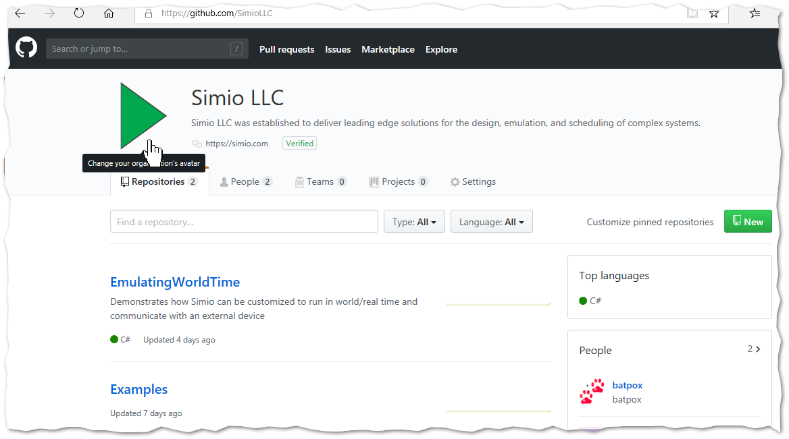

# Examining a Project

At the time of writing this document, the SimioLLC repository shows three projects:

1. Simio-Forum-and-GitHub
2. EmulatingWorldTime
3. Examples

As it just happens, the first repository contains documents (including this document), while the second and third are code repositories We’ll use these samples to show different ways to access these documents.

First, we’ll look at project based on code, which is a Simio User-Extension. Clicking on EmulatingWorldTime sends us to that project:

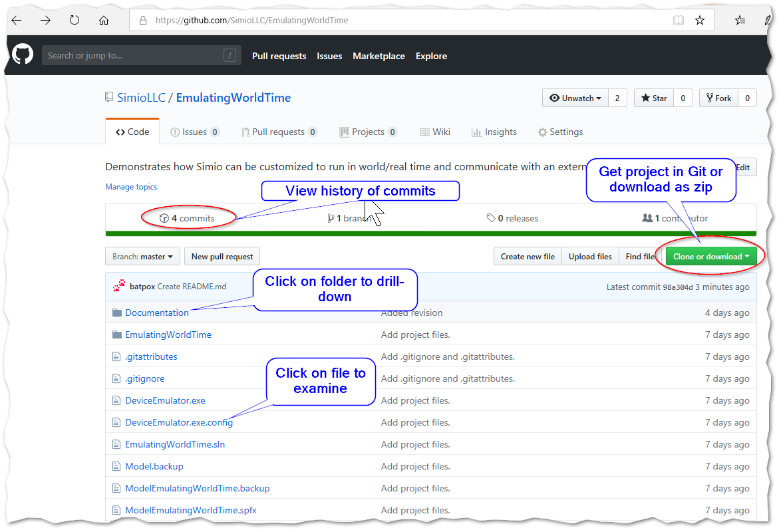

We can click on the folders and files directly, and GitHub will allow us to navigate into the folder, or give us a quick look at the contents of the files.

Clicking on the green “Clone or download” button presents two options. You can either

1. “Open in Desktop”, which means do a Git Clone, or
2. Download the root or “master” as a zipped (compressed) folder

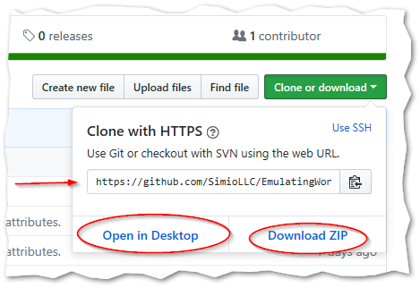

Not that it gives you a URL (the string beginning with <https://github...> to use for Git or SVN (SVN is another type of document repository). We’ll be using Git.

## Open in Desktop

With “Open in Desktop” we are going to create what is called a Git “clone” of the repository. This means a copy of the Simio Forum repository at a location of your choosing.

When you click the button your Windows OS will see if you have a default program to handle Git repositories.

### Opening the Project in Visual Studio

In this section, we’ll use this the Clone (i.e. “Open in Desktop”) option to open the project in VS (Visual Studio 2017). Start VS and create new project and then go to Team Explorer.

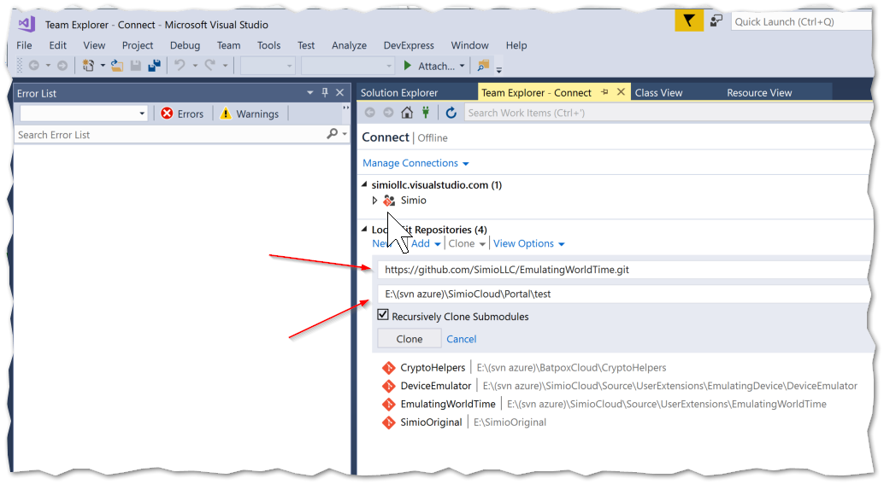

Take the URL that you copied from GitHub and paste it into the upper box, and then select a location on your desktop for the lower box. And then press the “Clone” button.

Within a few seconds you should see your project in a build-able state and ready to use.

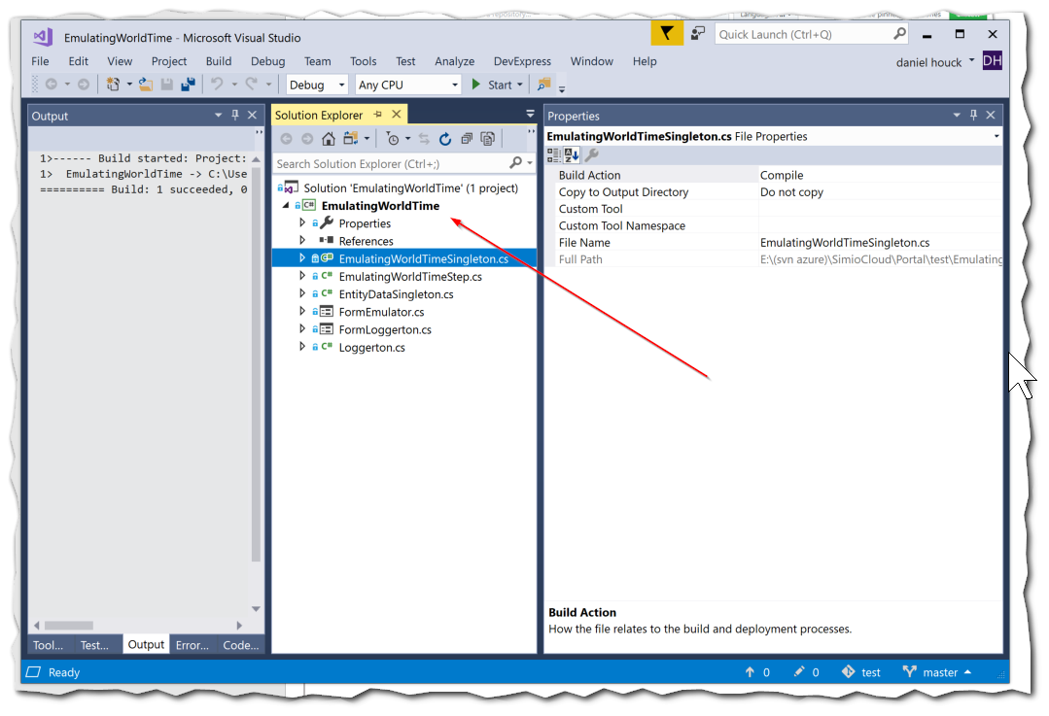

At this point, you not only have a full copy of the project, but you also can get the latest version if the project is updated. Furthermore, with permission of the author, you can make changes and request that the author “pull” your changes back into the project.

Use the View > Team Explorer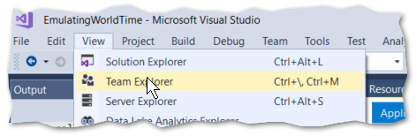 to bring up the Team Explorer window. From Home you can do things like view the history of Changes or Sync with the repository. 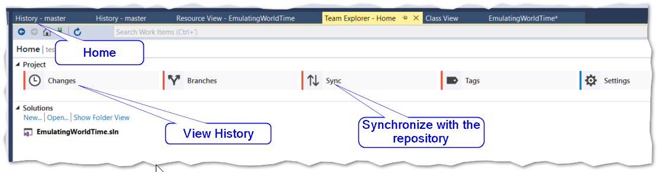

This ability to collaborate does not make sense for all Simio forum projects, but will be quite valuable for some.

Whether or not you choose to collaborate, the use of Git is useful to Simio as it makes it easier to make changes and have a complete history of submissions.

The full scope of Git is beyond this document, so please consult the References section of this document.

### Opening the Project in Some Other Git-Enabled App

You don’t have to use Visual Studio to synchronize these projects on your computer. You can also simply use the Windows file system to see and make changes to the projects. This is useful for non-VS projects, like documents or Simio projects.

On my computer, I have the free Tortoise Git application, so when I made this document, I used it to create a git repository on my local drive.

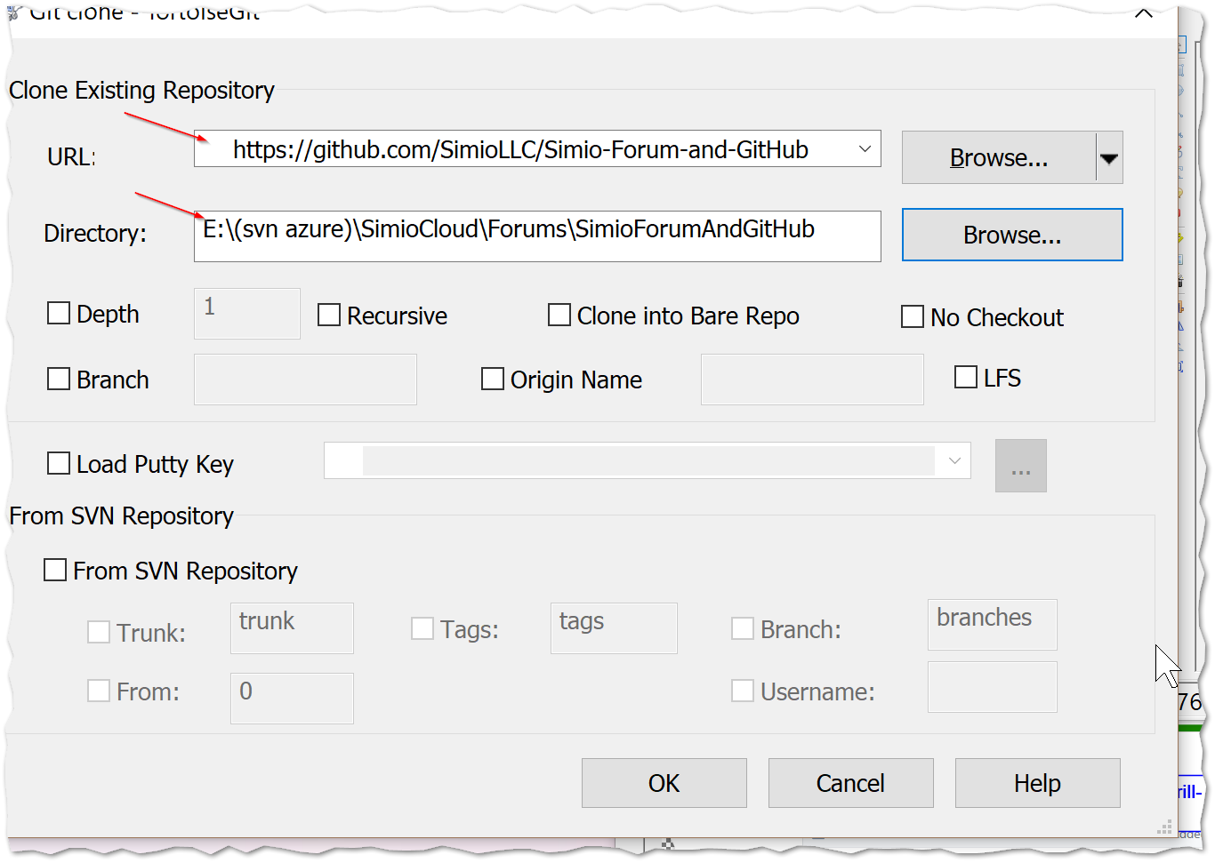

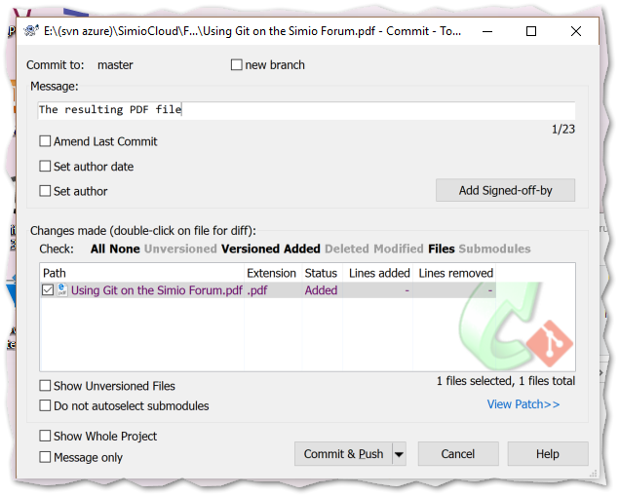

## Download Zip Option

This option is self-explanatory; when you click on this button you are prompted for a location for the Zip file, which you can extract and use any way you wish. This is very similar to how file distribution has always been done in the Simio Forum.

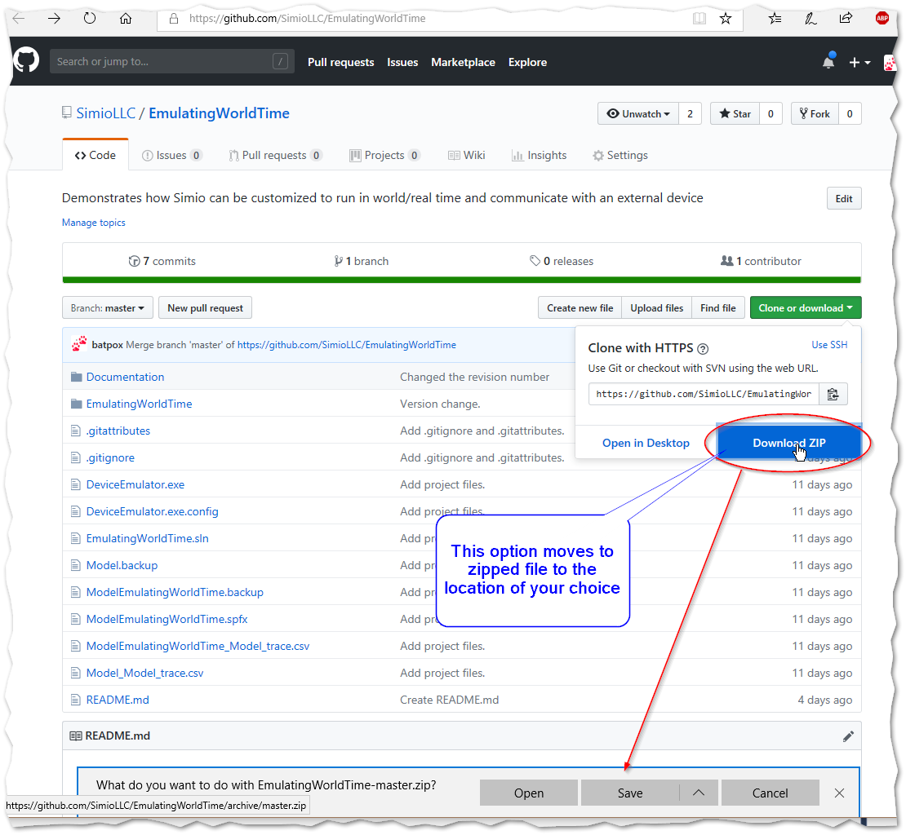

# Git References

Here are some Git and GitHub references.

Wikipedia explains GitHub:

<https://en.wikipedia.org/wiki/GitHub>

Tortoise Git Application integrates git with your Windows system. It is free and located here:

<https://tortoisegit.org/>

Wikipedia explanation of Git:

<https://en.wikipedia.org/wiki/Git>

The Git home site, which includes tutorials:

<https://git-scm.com/>

A good free Kindle book for learning Git is “Ry’s Git Tutorial”:

<https://www.amazon.com/Rys-Git-Tutorial-Ryan-Hodson-ebook/dp/B00QFIA5OC/ref=sr_1_1?ie=UTF8&qid=1547844178&sr=8-1&keywords=ry%27s+git+tutorial>